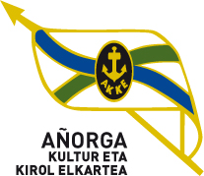 62. JOLAS ETXEA txapelketa

APIRILAK 23 10:00etan

GAZTEAK / JUBENILES

final zortzirenak

|  |  |  |
| --- | --- | --- |
| 10:00 H  1º partidua | Biain - Txintxurreta ( Aloñamendi ) | 22 |
| Moreno - Merino ( Errioxa ) | 0 |

|  |  |  |
| --- | --- | --- |
| 10:00 H  2º partidua | Arkaitz Baztarrika - Manex Garmendia ( Lapke ) | 22 |
| Pagola - Berasarte ( Hernani ) | 14 |

|  |  |  |
| --- | --- | --- |
| 10:00 H  3º partidua | Canaval - Cordon ( Oberena ) | 22 |
| David Uribe - Manex Balerdi ( Txukun Lakua ) | 3 |

|  |  |  |
| --- | --- | --- |
| 10:00 H  4º partidua | Ugalde - Lopez ( Oiarpe ) | 3 |
| Matxain - Usandizaga ( Gazteleku ) | 22 |