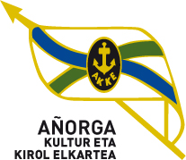 II. JOSE MANUEL IRIBAR saria

EKAINAK 11 16:00etan

KIMUAK / ALEVINES

Final erdiak

|  |  |  |
| --- | --- | --- |
| 16:00etan  1º partidua | Artaraz - Iruretagoiena (Joko Alai ) | 16 |
| Olaizola - Gabirondo ( Añorga-Tolosa) | 14 |

|  |  |  |
| --- | --- | --- |
| 16:00etan  2º partidua | Tapia - Huitzi ( Atzapar ) | 4 |
| Amiano - Orbegozo ( Añorga ) | 16 |

HAURRAK / INFANTILES

|  |  |  |
| --- | --- | --- |
| 16:00etan  3º partidua | Etxeberria - Izagirre ( Urretxu ) | 9 |
| Erkiaga - Arbaiza ( Joko Alai ) | 18 |

|  |  |  |
| --- | --- | --- |
| 16:00etan  4º partidua | Aimar Egiguren - Alberdi ( Ilunpe ) | 18 |
| Amiano - Ballarena ( Añorga | 16 |