IV. JOSE MANUEL IRIBAR saria 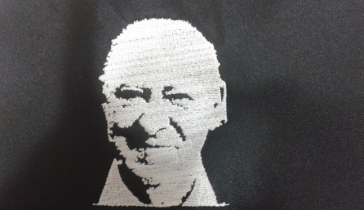

Martxoak 24 larunbata arratsaldeko 4etan AÑORGA pilota lekuan

**BENJAMINAK - VENJAMINES**

|  |  |  |  |
| --- | --- | --- | --- |
| SALABERRIA – SALABERRIA (Umoreona) | 16 | 12 | IZAGIRRE – ALBERDI (Txapagain) |

|  |  |  |  |
| --- | --- | --- | --- |
| AGESTA – MADARIAGA (Erreka) | 16 | 9 | USABIAGA – MANTEROLA (Hernani) |

|  |  |  |  |
| --- | --- | --- | --- |
| E. IMAZ – O. PABLO (Zizurkil) | 6 | 16 | H. ETXABE – O. ZUBIAGA (Bergara) |

**ALEBINAK – ALEVINES**

|  |  |  |  |
| --- | --- | --- | --- |
| TXINTXURRETA – ARTOLA (Hernani) | 16 | 15 | CONTRERAS – SANTESTEBAN (Erreka) |

|  |  |  |  |
| --- | --- | --- | --- |
| LEGARRETA – ELIZEGI (Umoreona) | 16 | 7 | J. ALTUNA – J. INSAUSTI (Tolosa) |

**INFANTILAK – INFANTILES**

|  |  |  |  |
| --- | --- | --- | --- |
| SALABERRIA – GARAÑO (Umoreona) | 18 | 6 | P. ELOSEGI – P. URDANPILLETA (Intza) |

|  |  |  |  |
| --- | --- | --- | --- |
| AGESTA - GARCIA (Erreka) | 18 | 8 | ARLUZIAGA – ALEGRIA (Hernani) |

|  |  |  |  |
| --- | --- | --- | --- |
| M. IZAGIRRE – X. SASIAIN (Zestoa) | 4 | 18 | ILLARREGI – MIKELARENA (Erreka) |

