IV. JOSE MANUEL IRIBAR saria 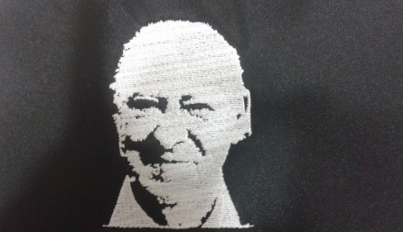

Martxoak 31 larunbata goizeko 9:30etan AÑORGA pilota lekuan

**ALEBINAK – ALEVINES**

**1º Partidua**

|  |  |  |  |
| --- | --- | --- | --- |
| Txintxurreta - Artola (Hernani) | 16 | 2 | Enaitz Ayerbe - Asier Vazquez ( Ataun ) |

**2º Partidua**

|  |  |  |  |
| --- | --- | --- | --- |
| Azkue - Astigarraga (Ilunpe) | 16 | 0 | Aritz Olaizola-Jokin Beristain ( Zumaia ) |

**3º Partidua**

|  |  |  |  |
| --- | --- | --- | --- |
| A. Mendiguren – B. Leonardo( Adurtza ) | 6 | 16 | Legarreta - Elizegi (Goizueta) |

**4º Partidua**

|  |  |  |  |
| --- | --- | --- | --- |
| Blázquez - Mugarza ( Aloñamendi ) | 16 | 0 | Martiarena - Markina ( Irurtzun ) |

**5º Partidua**

|  |  |  |  |
| --- | --- | --- | --- |
| Oses - Alzelai ( Legazpiko Gazteak ) | 16 | 0 | Etxabe-Unax Olaizola ( Zumaia ) |

**6º Partidua**

|  |  |  |  |
| --- | --- | --- | --- |
| A. Dorronsoro – A. altuna ( Tolosa ) | 10 | 16 | Ruiz - Iturrioz (Zazpiturri) |

