464. JOLAS ETXEA saria 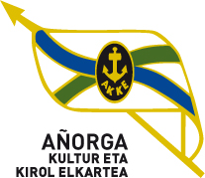

Apirilak 14 Larunbata goizeko 10:00etan AÑORGA pilota lekuan

**14 ABRIL a las 10h**

**GAZTEAK – JUVENILES**

|  |  |  |  |
| --- | --- | --- | --- |
| Marc Lima - Unai Berastegi (Aldabide) | 22 | 0 | Salaberria - Insausti (Hernani) |

**1º Partidua**

**2º Partidua**

|  |  |  |  |
| --- | --- | --- | --- |
| Pérez - Tatiegi (Aloñamendi) | 0 | 22 | Araña - Araña  (Gure Pilota) |

**3º Partidua**

|  |  |  |  |
| --- | --- | --- | --- |
| Argaluza - Egaña  (Kurune) | 10 | 22 | Elzaurdia - Zabaleta  (Gure Txokoa) |

**4º Partidua**

|  |  |  |  |
| --- | --- | --- | --- |
| O. Erostarbe – I. Aranburu (Eple) | 4 | 22 | Eñaut Izeta - Peio Olano (Añorga) |