IV. JOSE MANUEL IRIBAR saria 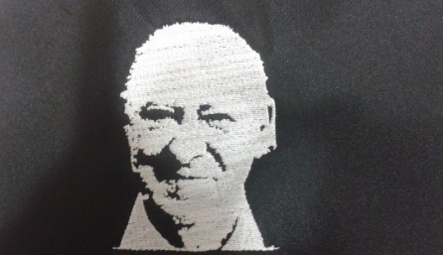

Apirilak 15 Igandea goizeko 9:30etan AÑORGA pilota lekuan

**INFANTILAK – INFANTILES**

**1º Partidua**

|  |  |  |  |
| --- | --- | --- | --- |
| Zabaleta-Aramburu  (Oiarpe) | 8 | 18 | Iraeta - Martin  (Hernani) |

**2º Partidua**

|  |  |  |  |
| --- | --- | --- | --- |
| Latorre – Uriarte  (Olgetan Orozko) | 4 | 18 | Jara – eskuza  (Herriaren Laudio) |

**3º Partidua**

|  |  |  |  |
| --- | --- | --- | --- |
| Aramburu - Aramburu  (Behar zana) | 2 | 18 | M. Arambarri – G. Larrañaga (Azkoiti) |

**4º Partidua**

|  |  |  |  |
| --- | --- | --- | --- |
| Barandiaran - Telleria  (Tartaloetxe) | 18 | 15 | Iriarte - Ezeiza  (Añorga) |

**5º Partidua**

|  |  |  |  |
| --- | --- | --- | --- |
| Etxaniz - Loza  ( Errioxa) | 18 | 4 | Lluzia – Pagola  (Gure Txokoa) |

**6º Partidua**

|  |  |  |  |
| --- | --- | --- | --- |
| Arrizabalaga - Ezama  (Ilunpe) | 18 | 14 | A. Urdangarin – E. Lizeaga (Mundarro) |

