IV. JOSE MANUEL IRIBAR saria 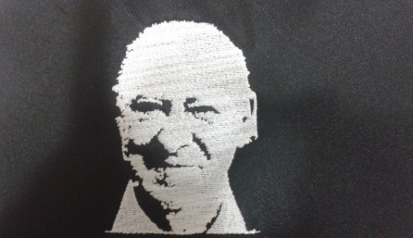

Apirilak 29 Igandea goizeko 9:30etan AÑORGA pilota lekuan

**ALEBINAK – ALEVINES**

**1º Partidua**

|  |  |  |  |
| --- | --- | --- | --- |
| Meulman – Aramburu (Behar Zana) | 6 | 16 | Oses –Alzelai (Legazpiko Gazteak) |

**2º Partidua**

|  |  |  |  |
| --- | --- | --- | --- |
| **Egiguren – Sarasua ( Ilunpe )** | 7 | 16 | Murua – Iturrioz ( Zazpiturri ) |

**3º Partidua**

|  |  |  |  |
| --- | --- | --- | --- |
| ALdazabal – Egaña ( Azkoiti ) | 16 | 5 | Gaminde – Ramirez ( Kurune ) |

**4º Partidua**

|  |  |  |  |
| --- | --- | --- | --- |
| Iruzubieta II – Olave ( Barberito ) | 16 | 6 | Iturbe – Eliazu ( Hernani) |

**5º Partidua**

|  |  |  |  |
| --- | --- | --- | --- |
| Izagirre – Aldea ( Elgoibar ) | 3 | 16 | Calvo – Idigoras (Markina) |

**6º Partidua**

|  |  |  |  |
| --- | --- | --- | --- |
| Lakar – Etxenike ( Gure Txokoa ) | 8 | 16 | Bereziartua – Oregi ( Lagunak Zornotza) |

**7º Partidua**

|  |  |  |  |
| --- | --- | --- | --- |
| Otaegi – Bidezabal (Ilunpe ) | 0 | 16 | Gomez – Arrizabalaga  (Legazpiko Gazteak) |

**8º Partidua**

|  |  |  |  |
| --- | --- | --- | --- |
| Iparragirre – Cestao ( Aduna) | 9 | 16 | Eskudero – Leonet ( Oiarpe) |

**9º Partidua**

|  |  |  |  |
| --- | --- | --- | --- |
| Babarro – Ibarluzea (Goierri) | 16 | 2 | Osa – Madinabeitia (Aloñamendi) |

**10º Partidua**

|  |  |  |  |
| --- | --- | --- | --- |
| Etxeberria – Sanchez (Eple) | 16 | 0 | Txintxurreta – Artola (Hernani) |

