IV. JOSE MANUEL IRIBAR saria 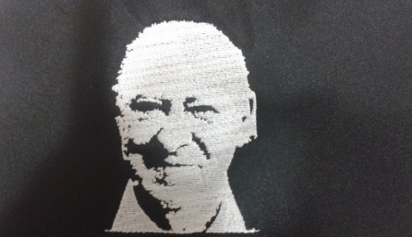

Apirilak 8 Igandea goizeko 9:30etan AÑORGA pilota lekuan

**INFANTILAK – INFANTILES**

**1º Partidua**

|  |  |  |  |
| --- | --- | --- | --- |
| **Balerdi - Mujika (Zazpiturri)** | 11 | 18 | **Garaiar - Etxarri(Hernani)** |

**2º Partidua**

|  |  |  |  |
| --- | --- | --- | --- |
| **Jon Etxaniz - Artea Goiburu (Azkoiti)** | 7 | 18 | **Barturen - Bilbao (Kurune)** |

**3º Partidua**

|  |  |  |  |
| --- | --- | --- | --- |
| **Urrutikoetxea - Iglesias (Zaratamo)** | 6 | 18 | **Andoni Elola - Oier Aramendi (Tolosa)** |

**4º Partidua**

|  |  |  |  |
| --- | --- | --- | --- |
| **Etxaniz - Loza ( Barberito I)** | 18 | 3 | **Oliden - Anduaga (Añorga)** |

**5º Partidua**

|  |  |  |  |
| --- | --- | --- | --- |
| **Lluzia - Pagola (Gure Txokoa)** | 18 | 15 | Salaberria - Garaño (Goizueta) |

**6º Partidua**

|  |  |  |  |
| --- | --- | --- | --- |
| **Ioritz Agirre - Lier Ruiz (Zestoa)** | 12 | 18 | **Aner Urdangarin - Eñaut Lizeaga (Mundarro)** |

**7º Partidua**

|  |  |  |  |
| --- | --- | --- | --- |
| **Arrizabalaga - Ezama (Ilunpe)** | 18 | 13 | Agesta - Garcia (Erreka) |

**8º Partidua**

|  |  |  |  |
| --- | --- | --- | --- |
| Illarregi - Mikelarena (Erreka) | 18 | 0 | **Garmendia - santamaria (Legazpiko gazteak)** |

