IV. JOSE MANUEL IRIBAR saria 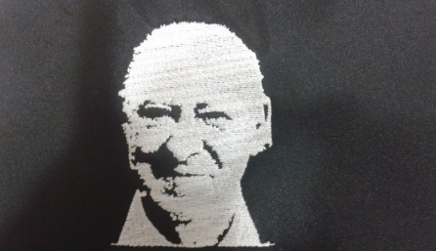

Maiatza 6 Igandea goizeko 9:30etan AÑORGA pilota lekuan

**BENJAMINAK – BENJAMINES**

**1º Partidua FINAL ZORTZIRENAK**

|  |  |  |  |
| --- | --- | --- | --- |
| **Oñate - Zufiria**  **( behar Zana )** | **16** | **12** | **Amets Izagirre - Xuban Barriola**  **( Ataun )** |

**2º Partidua**

|  |  |  |  |
| --- | --- | --- | --- |
| **Ohian Arandia / Beñat Elola**  **( Tolosa )** | **14** | **16** | **Unax Altuna / Martin Elola**  **( Tolosa )** |

**3º Partidua**

|  |  |  |  |
| --- | --- | --- | --- |
| **Iturralde - Artetxe**  **( Ilunpe)** | **16** | **7** | **Jon Arregi - Urtzi segurola**  **( Azkoiti )** |

**4º Partidua**

|  |  |  |  |
| --- | --- | --- | --- |
| **Salaberria – Salaberria**  **(Goizueta)** | **16** | **1** | **Mendizabal - Bilbao**  **( Kurune )** |

**5º Partidua**

|  |  |  |  |
| --- | --- | --- | --- |
| **Agesta – Madariaga**  **(Erreka)** | **16** | **5** | **Goñi – Korta**  **(Gure Txokoa)** |

**6º Partidua**

|  |  |  |  |
| --- | --- | --- | --- |
| **Haritz Etxabe - Oihan Zubiaga**  **(Bergara)** | **16** | **6** | **Oier Juaristi - Julen Etxaniz**  **( Azkoiti )** |

**7º Partidua**

|  |  |  |  |
| --- | --- | --- | --- |
| **Mikel Laso - Iñigo Leache**  **( Oberena )** | **16** | **3** | **Aratz Bikuña - Inar Barandiaran**  **( Ataun )** |

**8º Partidua**

|  |  |  |  |
| --- | --- | --- | --- |
| **Landa II – Landa I**  **( Tartaloetxea)** | **16** | **0** | **Laida Taberna - Amaiur Martinez**  **( Arkupe )** |

