IV. JOSE MANUEL IRIBAR saria 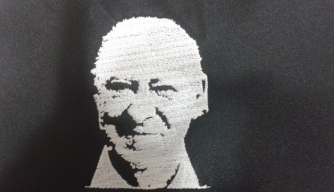

Ekainak 9 larunbata atsaldeko 16:00etan AÑORGA pilota lekuan

**ALEBINAK FINALERDIAK**

**1º Partidua**

|  |  |  |  |
| --- | --- | --- | --- |
| RAUL – ANTIMASMERES Lagunak ) | 16 | 5 | RUIZ - ITURRIOZ (Zazpiturri) |

**2º Partidua**

|  |  |  |  |
| --- | --- | --- | --- |
| OTAEGI – JUARISTI ( Txapagain ) | 16 | 12 | ETXEBERRIA – BEITIA ( Eple ) |

**BENJAMINAK FINALERDIAK**

**3º Partidua**

|  |  |  |  |
| --- | --- | --- | --- |
| ITURRALDE – ARTETXE (Ilunpe ) | 16 | 10 | ALTUNA – ELOLA ( Tolosa ) |

**4º Partidua**

|  |  |  |  |
| --- | --- | --- | --- |
| SALABERRIA – SALABERRIA (Goizueta ) | 16 | 8 | LASO – LEACHE (Oberena) |

**INFANTILAK FINALERDIAK**

**5º Partidua**

|  |  |  |  |
| --- | --- | --- | --- |
| JARA – ESKUZA (Laudio ) | 10 | 18 | IBARLOZA – PASCUAL ( Markina) |

**6º Partidua**

|  |  |  |  |
| --- | --- | --- | --- |
| ETXANIZ – LOZA ( Errioxa ) | 6 | 18 | AMIANO – ORBEGOZO ( Añorga ) |

