Jara - eskuza (Herriaren Laudio) IV. JOSE MANUEL IRIBAR saria 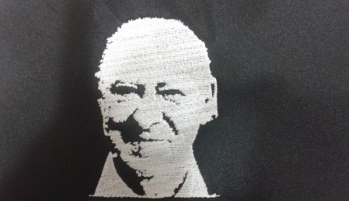

Ekainak 2 larunbata atsaldeko 16:00etan AÑORGA pilota lekuan

**ALEBINA LAURDENAK**

**1º Partidua**

|  |  |  |  |
| --- | --- | --- | --- |
| Aratz Otaegi - Juaristi  (Txapagain) | 16 | 3 | Gurrutxaga – Oregi  (Lagunak Zornotza) |

**2º Partidua**

|  |  |  |  |
| --- | --- | --- | --- |
| Etxeberria - Beitia  (Eple - Oberena) | 16 | 2 | Liher Ortiz - Ibai Arroitajauregi  (Iurreta) |

**INFANTILAK LAURDENAK**

**3º Partidua**

|  |  |  |  |
| --- | --- | --- | --- |
| Amiano - Orbegozo  (Añorga) | 18 | 1 | Garaiar – Etxarri  (Hernani) |

**4º Partidua**

|  |  |  |  |
| --- | --- | --- | --- |
| Jara – eskuza  (Herriaren Laudio) | 18 | 14 | Mikel Arambarri - Gotzon Larrañaga (Azkoiti) |

**5º Partidua**

|  |  |  |  |
| --- | --- | --- | --- |
| Etxaniz - Loza  ( Errioxa Bobadilla) | 18 | 8 | Barturen – Bilbao  (Kurune) |

**6º Partidua**

|  |  |  |  |
| --- | --- | --- | --- |
| Gorostidi - Gorostidi  (Zazpiturri) | 3 | 18 | Ibarloza – Pascual  ( Markina) |

